We need to add a cover page, table of contents, page numbers and use APA style referencing throughout this approximately 10 page doc
Heading – 16 Calibri (Heading)
Body – 12 Calibri (Body)

Abstract
The present paper provides a holistic analysis of the June 2020 cyberattack on Life Healthcare, critically examining how breakdowns in governance and information security exposed systemic weaknesses. Through a structured problem analysis, the report evaluates the organisation’s Corporate Governance, IT Governance, and Information Security Governance functions in relation to enterprise best practices. Using COBIT 2019, ISO/IEC 27001, and ISO/IEC 27005 frameworks, the study maps the existing governance structure, assesses key information-security roles, and designs an integrated governance model to strengthen oversight and resilience. Comparative evaluation of NIST and COBIT frameworks informs a recommended governance approach tailored to Life Healthcare’s operational context. Further sections include an IT risk assessment simulation, risk mitigation plan, and a training and awareness campaign proposal. Information, figures, and executive roles referenced herein are adapted from Life Healthcare’s Integrated Annual Reports (2021–2024) and publicly available corporate sources.

Declaration
We, the undersigned students, hereby declare that the contents of this report were prepared solely for academic purposes as part of the Information Technology Management and Governance (ITMG302) module. All corporate names, figures, models, and information referenced have been adapted from publicly available materials of Life Healthcare Group Holdings Limited, as well as recognised governance frameworks including King IV, ISO, and COBIT. We make no claim of ownership over any proprietary or published information belonging to Life Healthcare or related entities. The use of such material is strictly for academic analysis and evaluation in support of the course requirements.

Table of Contents
Abstract i
Declaration ii
Introduction 4
1. Case Study Analysis 5
2. IT Governance Mapping 6
3. InfoSec Roles Assessment 9
4. InfoSec Governance Model Design 11
4.1 Strategic Level 11
4.2 Tactical Level 11
4.3 Operational Level 12
5. Framework Analysis 13
6. Proposed Board/Executive InfoSec Structure 15
7. Operational Security Policies and Controls 17
8. Risk Management Plan 18
8.1 Risk Overview 18
8.2 Risk Assessment 18
8.3 Risk Mitigation 19
9. Training and Awareness Campaign 20
9.1 Life Healthcare Cybersecurity Awareness Training 20
9.2 Recommended Cybersecurity Awareness Campaign Enhancement 20
10. Conclusion 21
11. References 22
12. Appendices 24
12.1 Appendix A: Corporate Governance Framework 24
12.2 Appendix B: Direct and Control Model 25
12.3 Appendix C: Material Matters and Key Company Risks 26
12.4 Appendix D: Risk Appetite 27

Introduction
Corporate governance defines how an organization is directed and controlled to achieve its strategic objectives. Effective governance requires that an organization aligns both its technical and non-technical operations to deliver value and mitigate risk. The delivery of value extends beyond the strategic level and must also encompass tactical and operational processes. Successful governance emerges when strategic objectives are calibrated with a clear plan for accountability. This requires comprehensive policies, effective controls and a culture of awareness and compliance.
To support governance, management is the tactical and operational centric-model of executing the strategic directives in a continuous adjustment cycle. Governance determines who decides and why, while management ensures how those decisions are implemented. In contrast to this, failed governance is the inability of an organization to deliver value and meet its strategic objectives. This results from failures at one or more organizational levels, strategic, tactical or operational and their responsibilities.
This report will examine a case study of failed governance, the 2020 cyberattack on the Life Healthcare Group. The South African private healthcare provider incident serves as a lens through which governance will be evaluated across multiple domains, from corporate oversight and IT governance frameworks such as COBIT and ISO, to information security roles, risk management practices, operational policies, and awareness initiatives. The purpose of this evaluation is to not only analyse the case study but also propose a counteractive governance framework, that reinforces the current one (see Appendix A). Such structure will be designed to strengthen the organization’s corporate architecture and mitigate similar future failures from occurring.

1. Case Study Analysis
In June 2020, the Life Healthcare Group, one of South Africa’s largest private healthcare providers, experienced a severe cyberattack that disrupted its operations. The incident, classified as a ransomware-style attack, forced Life Healthcare to rollback multiple core IT systems into an offline state. These systems included their patient admission platforms, business processing applications and internal email servers (Life Healthcare, 2020). While clinical care processes were transferred to manual operations but essential functions such as billing, claims processing, supplier invoicing and financial reporting were significantly delayed (ITWeb, 2020). Such a disruption, that extended across multiple facilities, slowed down the organizational productivity during a period where the healthcare sector was already under strain due to the COVID-19 pandemic. Even though Life Healthcare stated that their patient medical records were not directly compromised, this still presented a difficult situation for the organization that deprived them of their value.
This case study represents more than just a technical breach, it demonstrates the consequences of failed governance in a corporate setting. As stipulated in the introduction, effective governance requires the continuous alignment of strategic objectives through accountability structures, policies, controls and risk management mechanisms (King IV Report, 2016). In the identified instance, the attack revealed the weaknesses in Life Healthcare’s corporate governance. The inability to anticipate, prevent and mitigate digital risks outlined the flawed system that attempted to align the strategic intent and the value delivery process. While Life Healthcare established a solid direction (see Appendix B), there was inadequate control mechanics in place to ensure that value is protected against risk. This instability grew further when the organization had to monitor the crisis, not having a backup system or effective strategy in place rather resorting to legacy manual operations that minimized value delivery. This highlighted the shortcomings in both the tactical level, preparedness and continuity planning, and the strategic level, board-level risk oversight (CyberPeace Institute, 2021).
The Life Healthcare cyberattack is a valuable case study that multiple facts can be derived from. Firstly, this incident showcases how governance failures originate across multiple organizational levels. At the strategic level, Life Healthcare’s board of directors insufficiently prioritized cybersecurity practices, leading to a system breach. At the tactical level, inadequate protection measures and risk management processes where found, causing the organization to fallback to legacy systems. While Life Healthcare has not specified the nature that caused the system compromise, at the operational level, there were day-to-day operations such as clicking untrusted links that propagated system vulnerabilities for attackers to exploit. As corporate governance is dynamic in nature, this fragile organizational model created issues in related aspects? (ITWeb, 2020).
By situating the case study under review within the broader discussion of corporate governance, management, information technology as well as information security, this analysis demonstrates the interconnected nature of governance success.

2. IT Governance Mapping
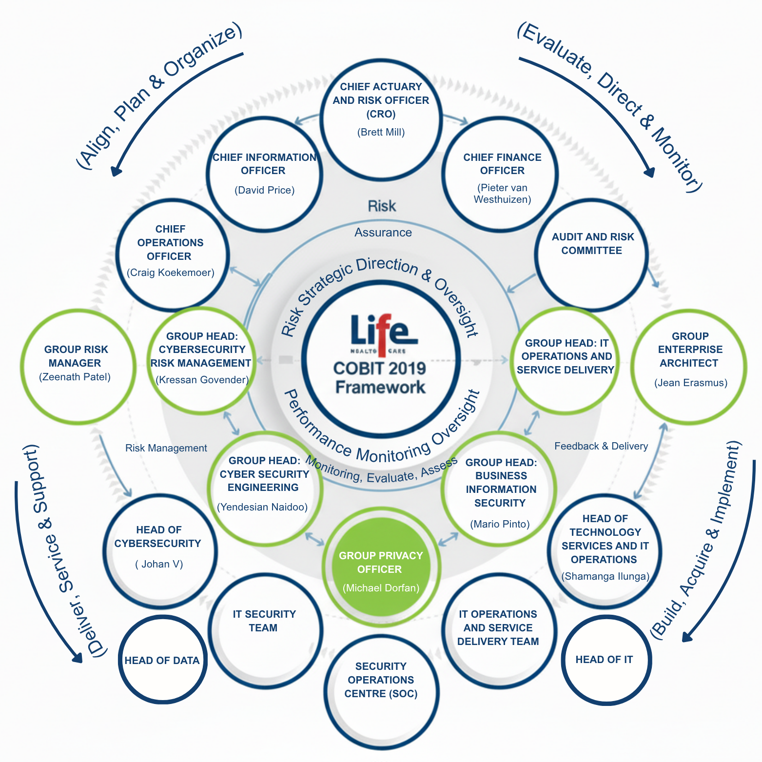
Information technology (IT) governance refers to a framework, or frameworks, that manages how organizations optimize their use of IT operations to support business objectives. (IBM, 2024) Reference Appendix B – Talk about the Key IT governance people:

COBIT: A Best Practice for IT Governance
COBIT (Control Objectives for Information and Related Technology) is a globally recognized framework for information technology (IT) management and governance. It’s a set of best practices and guidelines for organizations to align their IT strategies with their business goals, optimize IT resources, and manage IT-related risks.
Life HealthCare’s Cyberattack mapped out using COBITS five objectives:
- EDM (Evaluate, Direct and Monitor)
Overseen by the board of directors and ensures that IT risks are integrated into strategy and risk management. The governing body evaluates strategic options, directs senior management on the chosen strategic options and monitors achievement of the strategy. (ISACA,2019)
In Life HealthCare’s case the board did not sufficiently evaluate and direct a cybersecurity strategy. The lack of monitoring left risks invisible until the ransomware attack occurred.
- Audit and Risk Committee (Previously the Audit, Risk and Compliance Committee)
- Chief Finance Officer ~ Pieter van Westhuizen (Tied in with IT)
- Chief Actuary and Risk Officer ~ Brett Mill
- APO (Align, Plan and Organize)
This domain addresses the overall origination, translate strategy into tactical IT plans, supports activities for the enterprise IT, policies, and resource allocation.
Life HealthCare’s business continuity and disaster recovery planning were not effectively integrated. There was no proactive alignment between IT risk planning and critical healthcare operations. Their tactical readiness was poor due to underinvestment in cyber controls. This resulted in IT plans not being able to support the strategic need for resilient healthcare services.
- Chief Information Officer ~ David Price
- Chief Operations Officer ~ Craig Koekemoer
- Group Risk Manager ~ Zeenath Patel (Head of Risk)
- Group Head: Cyber Security Engineering ~ Yendesian Naidoo
- BAI (Build, Acquire and Implement)
Treats the definition, acquisition and implementation of I&T solutions and their integration into business processes. (ISACA,2019) They oversee developing and implementing secure IT systems and infrastructure.
In Life HealthCare situation their security controls were not properly built into critical IT assets. Their legacy IT systems lacked resilience, and they had inadequate backup and redundancy systems. The systems being vulnerable thus collapsed under ransomware conditions.
- Group Enterprise Architect ~ Jean Erasmus
- Group Head: IT Operations and Service Delivery
- Head of Technology Services and IT Operations ~ Shamanga Ilunga
- IT Operations and Service Delivery Team
- DSS (Deliver, Service and Support)
To address operational delivery and support of IT services, ensuring services are securely delivered and supported daily.
When Life HealthCare’s system was under attack their core services like billing, admissions, invoicing stopped functioning. Staff had to revert to manual processes which reduced efficiency and risking increasing errors.
Business continuity was directly impacted because service delivery was disrupted.
- Group Head: Cybersecurity Risk Management ~ Kressan Govender
- Head of IT ~ Lerato Setlogomi
- Head of Cybersecurity ~ Johan V
- Head of Data ~ Naimen Rangila
- IT Security Team
- Security Operations Centre (SOC)
- MEA (Monitor, Evaluate and Assess)
MEA addresses the organizations performance monitoring and conformity of IT to internal performance targets, internal control objectives and external requirements. (ISACA,2019)
Life HealthCare had no effective monitoring mechanisms like penetration testing or security audits. Their KPIs and governance reporting around cybersecurity were insufficient. They only detected risks after the breach, when the attack already made an impact.
- Group Privacy Officer ~ Michael Dorfan
- Group Head: Business Information Security ~ Mario Pinto
- Group Risk Manager ~ Zeenath Patel (Head of Risk)

3. InfoSec Roles Assessment
Information Security (InfoSec) roles are critical components of effective IT governance, as they ensure the protection of sensitive information, alignment with organizational objectives and compliance with regulations. Frameworks like ISO 27001 emphasize the need for clearly defined roles and responsibilities within an Information Security Management System (ISMS), including leadership oversight, strategic planning, operational execution and continuous monitoring (International Organization for Standardization, 2013). Similarly, COBIT 2019 highlights the importance of assigning responsibilities across governance domains, such as APO (Align, Plan, and Organize) for role definition and MEA (Monitoring, Evaluate, and Assess) for performance oversight as identified in section 2 (ISACA, 2019). In context of Life Healthcare’s 2020 cyberattack, assessing these roles reveals both established structures and significant failures that contributed to the governance breakdown.

3.1 Responsibility Matrix
Table 1: Responsibility Matrix for Life Healthcare InfoSec Roles
Function/ Role | CFO | CIO | CRO | ARC | GCSE | GPO | GRM | GBIS | GEA | GITOP | HITOP | HCS | ITOP | SOC | ITSC
Develop Security Policy | I | A | C | C | R | C | C | R | C | I | I | I | I | I | C
Incident Response | I | C | I | C | C | I | C | C | I | C | C | R | R | A | C
Risk Assessment | C | C | A | A | C | C | R | C | C | I | I | I | I | I | C
POPIA Compliance | I | C | I | C | C | A | C | C | I | I | I | I | I | I | I
Access Control Management | I | C | I | I | R | C | I | C | C | R | C | A | A | R | C
Business Continuity Planning | C | A | R | A | C | C | C | I | C | R | C | C | I | I | C
Note: R – Responsible | A – Accountable | C – Consulted | I – Informed

3.2 Strategic Level
The strategic layer defines governance direction, allocates resources, and evaluates performance. The CIO and CRO maintain accountability (“A”) for policy formulation and risk oversight, while the Audit and Risk Committee (ARC) ensures alignment with enterprise risk appetite and regulatory compliance. The IT Steering Committee (ITSC) bridges business strategy and IT governance, ensuring InfoSec goals are embedded in organizational planning.
This top-down oversight supports COBIT’s EDM domain and ISO’s leadership and continual improvement requirements.

3.3 Tactical Level
The tactical layer translates executive direction into frameworks, standards, and procedures. The Group Head of Cybersecurity Engineering (GCSE) leads the development of technical security controls and architectures, supported by the Group Business Information Security (GBIS) and Group Risk Manager (GRM) to integrate risk-based approaches. The Group Privacy Officer (GPO) ensures POPIA and data protection compliance. This layer enforces alignment across business units, acting as the operationalization engine for strategic policies. Their coordination directly supports COBIT’s APO (Align, Plan, and Organize) and DSS (Deliver, Service, and Support) processes.

3.4 Operational Level
The operational layer executes controls, responds to incidents, and manages day-to-day operations. The Head of Cybersecurity (HCS) and SOC lead incident detection, response, and monitoring, while IT Operations ensures systems availability and access control enforcement. This level provides feedback and performance metrics to the tactical and strategic levels, fulfilling COBIT’s MEA (Monitor, Evaluate, and Assess) governance principle. The lack of integration between these layers during the 2020 cyberattack highlighted the need for improved communication channels and escalation protocols between SOC and governance committees.

4. InfoSec Governance Model Design
Information Security management at Life Healthcare is currently heavily focused on operational security functions and technical controls, even after the event of the June 2020 cyberattack. As identified in section 2 and 3: key roles such as the CIO (David Price), ARC, GPO, GCSE and GRM provide substantial support for the day-to-day operations, compliance and incident management. In addition to this, the operational teams, SOC and IT operations, are responsible for executing policies, monitoring relevant systems and responding to incidents. While this structure presents a comprehensive security posture, there is a lack of holistic IT governance, particularly in areas of strategic alignment, value delivery, performance monitoring, and enterprise risk management.
Historically, Life Healthcare has presented numerous instances reinforcing this gap. The dissolution of the Risk, Compliance, and IT Governance Committee in May 2024, which was merged into the current ARC, reflects the low prioritisation of IT governance and its executive functions influencing Information Security. Furthermore, in April 2024, the CFO temporarily oversaw IT operations, demonstrating that IT was often regarded as a financial cost centre rather than a strategic enabler. Life Healthcare’s governance structure doesn’t present the absence of IT governance, as there is an IT Steering Committee, suggesting that IT governance exists but it is primarily viewed through a security lens rather than overall enterprise IT strategy.
Evidently, there is a need for a refined InfoSec governance model that includes strategic oversight mechanisms. This model is organized into three hierarchical layers:

4.1 Strategic Level
Direction and Oversight: This layer, as seen in section 3, includes the CIO, CFO, CRO, the IT Steering Committee and the Audit and Risk Committee. To strengthen strategic governance, specifically that pertaining to IT, we introduce a new executive member: the Chief Information Governance Officer (CIGO) or the equivalent, complementing the CIO and COO. This role would focus on aligning IT and InfoSec initiatives with organisational objectives, ensuring that investments IT deliver value and establishing executive-level IT strategy. This role would work in partnership with executive portfolios such as the Enterprise Architect, with close collaboration with the IT Steering committee specifically focusing on holistic IT governance. We also propose reviving the IT Governance committee to be a separate entity from the ARC as an enterprise of this scale requires a specialized body to target it’s resources to this cause alone.

4.2 Tactical Level
Policy Implementation and Risk Management: To aid the functions of the CIGO in efforts to execute the proposed governance model, existing roles such as the GCSE, GBIS, GRM, GPO will include actionable policies that are translations of the executive directives of IT governance at the board level. Enhancing this, a Group IT Governance Lead is introduced to effectively oversee these policies. Information Security Governance related documents at the tactical level should additionally mandate the respective measures that ensure this IT value delivery, possibly introducing new compliance clauses needed to complement the current Information Security Management System in place. New operational security policies and controls will be discussed specifically in section 7.

4.3 Operational Level
Execution and Monitoring: The last layer comprises of the HITOP, HCS, ITOP, SOC, ITSC. Life Healthcare has established a strong foundation for IT governance through the HITOP and the respective operations teams that already complete the required execution and control functions in relation to InfoSec governance and the overall IT governance. The improved strategic and tactical levels now formalize an escalation path from the operational teams to tactical then finally strategic, allowing for administrative procedures to be transferred into tactical reports that are benchmarked against the directives then refined to be board-ready documents.

5. Framework Analysis
ISO 27001:
The ISO 27001 framework specifies the requirements for establishing, implementing, maintaining and continuously improving an ISMS (Information Security Management System). These requirements include the evaluation and treatment of information security risks. This framework’s primary focus is to establish a certified Information Security Management System (ISMS). It does risk-based controls, policies, procedures, and continuous improvement. This is a generic framework which are intended to be applied to any type of organization. Certification: ISO 72001 is certifiable.
Strengths: ISO 27001 is an internationally recognised certifiable standard. Has prescriptive controls and risk treatment process. This framework is strong for operational control and compliance.
Weaknesses: It is vague on governance and accountability at board level. ISO 72001 is operational and requires a lot of documentation.
Life Healthcare already indicates the use of ISO 27001 certification as part of its risk management disclosures (Life Healthcare, 2021). During the ransomware attack in 2020 the organization demonstrated weaknesses at the strategic and governance levels where ISO 27001 supports compliance and operational control. ISO 27001 does not ensure adequate board level oversight, strategic alignment, or accountability across departments.
NIST Cybersecurity Framework (CSF):
NIST Cybersecurity Framework (CSF) 2.0 helps organizations of all types and sizes, whether public or private, to manage and reduce cybersecurity risks. This framework provides a clear structure for understanding and organizing cybersecurity goals. It helps organizations assess, prioritize, and communicate their cybersecurity efforts. The framework points to other resources and best practices that show how to achieve your company’s goals (NIST CSWP 29, 2024). This framework’s primary focus is based on cybersecurity risk management. It identifies, protect, detect, respond, recover practical controls and maturity.
Strengths: This framework is very practical and vendor neutral control catalogue. NIST is excellent for cyber defence and incident response manual. Used for mapping to controls.
Weaknesses: NIST is not a governance framework. Thus, weaker on-board oversight and organisation-wide accountability.
NIST (CSF) can enhance Life Healthcare’s cyber resilience and incident response capabilities. However, NIST cannot address broader governance and oversight deficiencies at the board and management levels that allows vulnerabilities to persist. This framework is more suitable as a supplementary operational tool, rather than a standalone governance framework.

COBIT 2019:
Control Objectives for Information and Related Technology is a framework for information technology management and governance. Created by ISACA (System Audit and Control Association) and ITGI (IT Governance Institute). This framework provides a set of best practices and guidelines for organizations to align their IT strategies with their business goals, optimize IT resources, and manage IT-related risks. COBIT 2019’s primary focus is Enterprise IT governance and management. The align of IT with business strategy, accountability, value and risk governance
Strengths: This framework is strong at board level. It defines governance objectives like EDM, APO, BAI, DSS, MEA, and excellent for linking IT activities to strategic outcomes and responsibilities
Weaknesses: COBIT 2019 is a high-level framework and is not prescriptive enough for specific technical controls or certification. It needs to be paired with operational standards.
COBIT 2019 provides the most comprehensive governance solution. Life Healthcare’s breach in 2020 revealed failures that fall within COBIT’s governance domains namely, strategic oversight, risk management and continuity planning
Recommended Framework for Life HealthCare:
From the above information it is clear that COBIT 2019 is the most appropriate framework for Life Healthcare. The framework directly addresses the governance failures highlighted by the organizations 2020 cyberattack. While ISO 27001 supports operational control and compliance, and NIST strengthens incident response, COBIT provides the strategic, governance, and management structure needed to link IT operations to corporate objectives.
By adopting COBIT 2019 framework the organization will have clear accountability between the Board, Executive Management, and IT functions. COBIT 2019 enhances strategic alignment of cybersecurity and corporate governance under King IV. The framework also supports risk-based decision making and value delivery across the enterprise. It will also seamlessly integrate with Life Healthcare’s existing ISO 27001 certification and ISO 31000 risk management framework (Life Healthcare Annual Report, 2021). Lastly, the organizations’ ability to evaluate, direct, and monitor IT related risks and performances will be strengthened.

6. Proposed Board/Executive InfoSec Structure
Lessen bullet points, also focus on the Executive/Strategic/Leaders as required
Strategic Level (Direct and Control):
This level provides direction and oversight for information security across the organisation. Controlled by the Board of Directors and Executive Leaders.
- Board of Directors
  - Directives: As part of the corporate strategy, the Information Security Strategy needs the Board of Directors approval.
  - Risk Management:
- Risk, Compliance & IT Governance Committee (RCITComm)
- Chief Executive Officer (CEO)

Tactical Level (Control and Coordinate):
Executive Management and InfoSec Leaders translate directives into actionable policies, frameworks, and control systems.
- Chief Information Security Officer (CISO)
- Chief Information Officer (CIO)
- Chief Risk Officer (CRO)
- Information Security Steering Committee

Operational Level (Directive Execution and Awareness):
In the operational level technical and functional teams implements InfoSec. They execute daily controls, maintain systems and promote awareness.
- Security Operations Centre (SOC):
- IT Security Administrators
- HR and Training Unit
- Internal Audit

Directives: Board of Directors, RCITComm, CEO
Control: CISO, CIO, Internal Audit, SOC
Risk Management: CRO, RCITComm, CISO
Organisation: InfoSec Steering Committee
Awareness: HR, CISO-led programs
Directive Execution: SOC, IT Admins
Best Practices: ISO 27001, COBIT, NIST guidelines

7. Operational Security Policies and Controls
To strengthen Life Healthcare’s resilience against incidents like the 2020 ransomware attack, a robust set of operational security policies and controls is implemented, aligning with the hybrid governance framework integrating COBIT 2019, ISO 27001, and NIST CSF. These policies ensure daily enforcement and monitoring, protecting critical assets such as patient data and IT systems while supporting the strategic and tactical directives established for the organization.
Access control and identity management enforce least-privilege access for all users, requiring multi-factor authentication (MFA) and quarterly privilege reviews by the IT security team to prevent unauthorized access, addressing vulnerabilities exposed in the ransomware incident. Data classification and handling procedures categorize information assets as public, internal, confidential, or restricted, with encryption mandated for sensitive patient records during transmission and storage, aligning with ISO 27001’s prescriptive controls.
Threat detection and response are enhanced through endpoint protection and network monitoring, utilizing antivirus software, intrusion detection systems, and weekly vulnerability scanning managed by the Security Operations Centre (SOC). These measures, guided by COBIT’s DSS05 for managed security services, ensure real-time threat alerts and rapid incident escalation. Patch management protocols require critical updates within 48 hours of release to prevent exploitation of outdated systems, a key factor in the 2020 attack. Logging and auditing procedures capture all system activities, with daily log reviews and six-month retention for forensic analysis, supporting compliance with POPIA and GDPR.
Employee compliance is reinforced through bi-annual phishing and breach simulations, fostering vigilance and aligning with the organization’s commitment to a secure operational environment. Key performance indicators, such as mean time to detect threats, are monitored to ensure continuous improvement, enabling Life Healthcare to deliver value while mitigating cyber risks effectively (ISACA, 2019; International Organization for Standardization, 2013; NIST, 2024).

8. Risk Management Plan
Input feedback here: No

8.1 Risk Overview
Building on the proposed governance structure, in this section we evaluate Life Healthcare’s critical information and operational risks then proposed a structured risk mitigation plan. Risk is defined as being the likelihood of an event, positive or negative, occurring Risk Management in particular is an integral part of successful corporate governance, ensuring that any organization does not lose value through the exploitation of its assets. As emphasised in ISO 27005 and COBIT’S EDM and MEA domains, risk management, especially effective risk management ensures resilience, accountability, and continuous improvement across strategic, tactical, and operational levels.

8.2 Risk Assessment
The 2020 cyberattack revealed multiple governance and technological vulnerabilities that the organisation has. Primarily we can derive occurrences of risks as: cybersecurity threats, business continuity failures, compliance breaches, reputational damage and strategic oversight. Cybersecurity risks specifically accelerate in growth during the presence of outdated systems and inadequate patch management. Operational continuity risks are the product of insufficient backup infrastructure and the lack of a disaster recovery sub policy, an InfoSec governance document that mandates the need for redundancy within organisational systems, something that evidently Life Healthcare did not consolidate enough. These operational risks then give arise to legal and compliance risks, which were firstly adhere to but once Life Healthcare’s systems were compromised, this led to the loss of patient trust. Reputational risk arises from negative public perception following data loss, while strategic risk highlights inadequate board-level cyber oversight and fragmented decision-making. The following table structure showcases the detailed overview of risks associated with Life Healthcare’s cyberattack incident:
Table 1: Risk Management for Life Healthcare
Risk ID | Description | Likelihood | Impact | Mitigation Strategy and Responsible Level
R1 | Cyberattack exploiting legacy systems and weak patching | High | Critical | Implement automated patch management, system upgrades, and quarterly penetration tests (Operational)
R2 | Business continuity failure due to absent disaster recovery plan and policy | Medium |  | Develop ISO 22301-aligned BCP/DRP; perform semi-annual simulation tests (Tactical)
  High
R3 | POPIA and GDPR non-compliance in patient-data handling | Medium |  | Appoint Data Protection Officer, conduct privacy impact assessments, update consent procedures (Strategic / Tactical)
  High
R4 | Insufficient cyber-risk oversight at board level | Medium
  Critical
  Integrate cybersecurity into enterprise risk dashboards; include CISO in board reporting (Strategic)
R5 |  | High | Medium | Implement continuous training, phishing simulations, and KPI-based awareness tracking (Operational)
  Low staff cyber-awareness leading to phishing vulnerability

8.3 Risk Mitigation
These mitigation strategies are performed by a specific level in the Strategic, Tactical and Operational governance model for Life Healthcare identified earlier in sections 3 and 4. Strategic-level risks, R3 and R4, fall under the Board’s Risk and IT Governance Committee (RCITComm) to ensure executive accountability and regulatory compliance. R2 is identified to be a risk associated with the tactical level as this relates to the plans and policies in place to ensure that the directives are met. To complete this, R1 and R5 are both operational-level responsibilities as the directly connect to the lower-level procedures implemented by Life Healthcare’s operational team. Continuous evaluation under COBIT’s MEA domain establishes feedback loops that assess control performance and inform future policy refinement.

9. Training and Awareness Campaign

9.1 Life Healthcare Cybersecurity Awareness Training
Life Healthcare has established internal training programmes designed to strengthen its defences against cyber threats. In its Integrated Annual Report (2021), the organisation notes that employees regularly receive information security and cybersecurity awareness training. This forms part of a broader effort to address the rising risks of cybercrime and data breaches, which have become more prominent with the increase in remote and hybrid work.
At present, these training sessions are incorporated into Life Healthcare’s overall security framework, including its Information Security Management System (ISMS), physical and logical access controls, and the Security Operations Centre (SOC). However, the initiative functions more as part of the company’s operational security posture than as a standalone, visible awareness campaign with clear phases and targeted communication strategies.

9.2 Recommended Cybersecurity Awareness Campaign Enhancement
To strengthen Life Healthcare’s existing cybersecurity awareness programme, it is recommended that the organisation introduce specialised training tracks tailored to different staff groups, such as clinical personnel, administrative employees, executives, and remote workers. By using realistic, role-specific scenarios, the training can become more practical and engaging, helping participants better relate to the potential threats they may encounter in their daily work.
In addition, Life Healthcare could adopt a campaign-style approach to awareness, incorporating visually engaging posters, short email scripts, and brief video clips to build ongoing visibility across the organisation. Each campaign could conclude with a short quiz or simulated exercise to reinforce learning and assess understanding.
To further promote a culture of security mindfulness, the organisation might distribute regular email updates on emerging cyber threats and attack trends. A monthly reminder to update passwords could also serve as a simple but effective measure to strengthen individual accountability and safeguard sensitive information.

10. Conclusion
The 2020 Life Healthcare cyberattack serves as a defining case for understanding how governance breakdowns can expose critical weaknesses in information security, corporate oversight, and operational resilience. This report demonstrated that while Life Healthcare maintains an established governance foundation aligned with King IV, ISO 27001, and COBIT 2019, the attack revealed a lack of integration across strategic, tactical, and operational layers. Through mapping, assessment, and the design of a renewed governance framework, this analysis underscores the need for clearer accountability, stronger board-level cyber oversight, and more adaptive risk management practices.
Recommendations such as enhanced staff awareness programmes, specialised training for executives and clinicians, and proactive risk monitoring will further strengthen the organisation’s security posture. By aligning COBIT’s governance domains with ISO’s operational rigour and NIST’s response structures, Life Healthcare can achieve a mature, resilient cybersecurity culture, one that not only protects patient data but also sustains organisational trust and value creation in an increasingly digital healthcare environment.

11. References
- CyberPeace Institute. (2021). Cyberattacks on healthcare: Life Healthcare, South Africa. Retrieved from https://cyberpeaceinstitute.org
- ITWeb. (2020, August 25). Life Healthcare reveals damage caused by cyber-attack. Retrieved from https://www.itweb.co.za
- King IV Report. (2016). Report on corporate governance for South Africa 2016. Institute of Directors in Southern Africa.
- Life Healthcare. (2020a). Cyber incident Q&A. Retrieved from https://www.lifehealthcare.co.za
- Reuters. (2020, June 9). South Africa’s Life Healthcare hit by cyber attack, systems offline. Retrieved from https://www.reuters.com
- CyberPeace Institute. (2021). Cyberattacks on healthcare: Life Healthcare, South Africa. https://cyberpeaceinstitute.org/report/2021-03-CyberPeaceInstitute-SAR001-Healthcare.pdf
- Information Security Management and Assurance: A Call to Action for Corporate Governance. (2000). American Institute of Certified Public Accountants. http://www.aicpa.org/assurance/systrust/press/report_b.htm
- Institute of Directors in Southern Africa. (2016). King IV report on corporate governance for South Africa 2016. https://www.iodsa.co.za/page/KingIVReport
- International Organization for Standardization. (2013). ISO/IEC 27001:2013. Information technology, Security techniques Information security management systems, Requirements. International Organization for Standardization.
- ISACA. (2019). COBIT 2019 framework: Introduction and methodology. https://www.isaca.org/resources/cobit
- ITWeb. (2020, August 25). Life Healthcare reveals damage caused by cyber-attack. https://www.itweb.co.za/article/life-healthcare-reveals-damage-caused-by-data-breach/rW1xLv59YPGvRk6m
- Life Healthcare Group. (2020). Integrated annual report 2020. https://www.lifehealthcare-online.co.za/life-healthcare-iar-2021/corporate-governance-overview.php
- Life Healthcare Group. (2020a). Cyber incident Q&A. https://www.lifehealthcare.co.za/media/3177/20200609_life-healthcare-cyber-incident_web-q-and-a-final.pdf
- Reuters. (2020, June 9). South Africa’s Life Healthcare hit by cyber-attack, systems offline. https://www.reuters.com/article/technology/south-africas-life-healthcare-hit-by-cyber-attack-idUSKBN23G0MY
- Life Healthcare Group Holdings Limited. (2021). Integrated annual report 2021. https://www.lifehealthcare.co.za/media/3600/life-healthcare-integrated-annual-report-2021-final.pdf

https://www.ibm.com/think/topics/it-governance
https://www.lifehealthcare.co.za/media/3177/20200609_life-healthcare-cyber-incident_web-q-and-a-final.pdf?utm
https://www.lifehealthcare-online.co.za/life-healthcare-iar-2021/corporate-governance-overview.php
https://www.itweb.co.za/article/life-healthcare-reveals-damage-caused-by-data-breach/rW1xLv59YPGvRk6m?utm
https://www.itweb.co.za/article/life-healthcare-group-hit-by-cyber-attack-amid-covid-19/JBwErvnBK4av6Db2?utm

https://nvlpubs.nist.gov/nistpubs/CSWP/NIST.CSWP.29.pdf

https://www.reuters.com/article/technology/south-africas-life-healthcare-hit-by-cyber-attack-idUSKBN23G0MY/?utm
https://cyberpeaceinstitute.org/report/2021-03-CyberPeaceInstitute-SAR001-Healthcare.pdf?utm
https://pmc.ncbi.nlm.nih.gov/articles/PMC11618010/?utm
https://www.wallarm.com/what/what-is-cobit-control-objectives-for-information-technology
https://www.isaca.org/resources/news-and-trends/industry-news/2019/employing-cobit-2019-for-enterprise-governance-strategy
https://www.lifehealthcare-online.co.za/life-healthcare-iar-2021/how-we-manage-risk.php?utm

12. Appendices

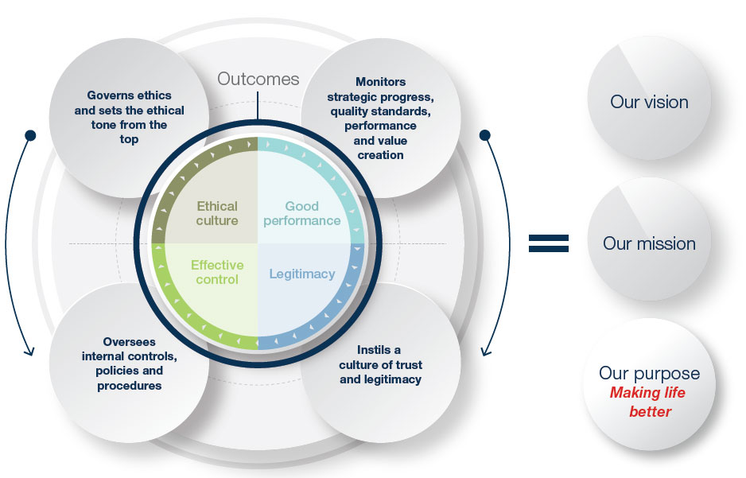
12.1 Appendix A: Corporate Governance Framework

Source: Life Healthcare Group Holdings Limited. (2021). Integrated Annual Report 2021 (Corporate Governance Overview page). Retrieved from https://www.lifehealthcare-online.co.za/life-healthcare-iar-2021/corporate-governance-overview.php
Appendix A: Life Healthcare Corporate Governance Framework
This diagram illustrates Life Healthcare’s governance philosophy and structure as presented in the 2021 Integrated Annual Report. It links King IV governance outcomes: ethical culture, good performance, effective control and legitimacy, to the Board’s roles in monitoring strategy, ethics, controls and trust. It further aligns these outcomes to the organisation’s vision, mission and purpose of “Making life better.” (Life Healthcare, 2021).

12.2 Appendix B: Direct and Control Model
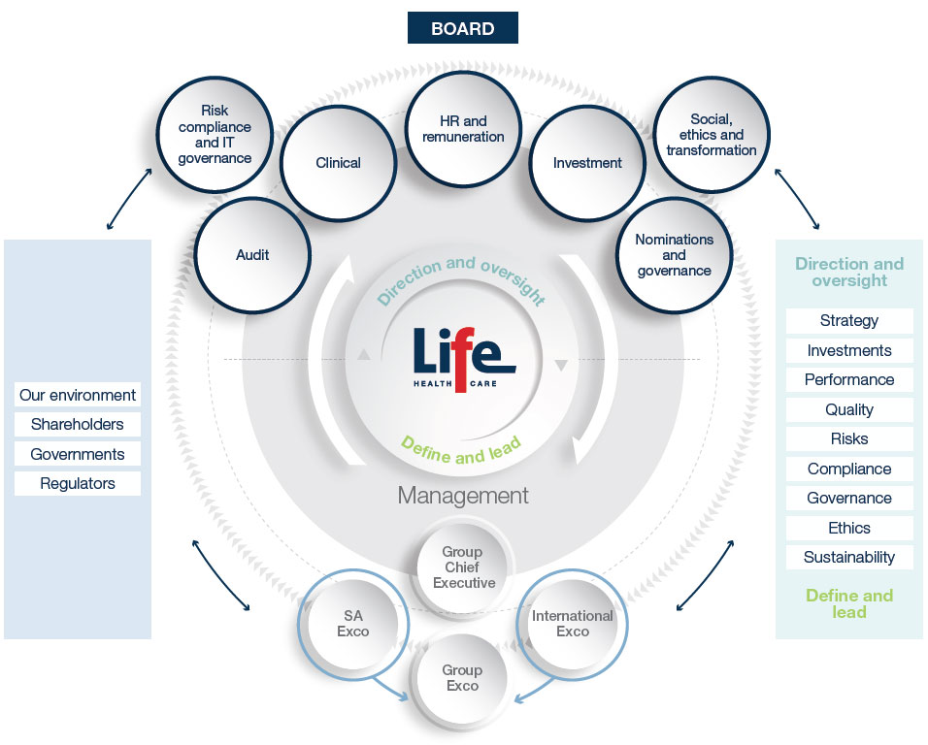
Source: Life Healthcare Group Holdings Limited. (2021). Integrated Annual Report 2021 (Corporate Governance Overview page). Retrieved from https://www.lifehealthcare-online.co.za/life-healthcare-iar-2021/corporate-governance-overview.php
Appendix B: Life Healthcare Board and Executive Direct and Control Model
This diagram illustrates the relationship between Life Healthcare’s Board, its committees, and executive management. The Board provides direction and oversight through key committees (Risk, Compliance and IT Governance; Audit; HR and Remuneration; Investment; Clinical; Social, Ethics and Transformation; and Nominations and Governance). Management, led by the Group Chief Executive, Peter Wharton-Hood, executes these directives through the SA Executive Committee, International Executive Committee, and Group Executive Committee. The model demonstrates how Life Healthcare aligns King IV governance principles, linking strategic oversight, ethical leadership, risk management, and performance accountability across corporate levels(Life Healthcare, 2021)..

12.3 Appendix C: Material Matters and Key Company Risks
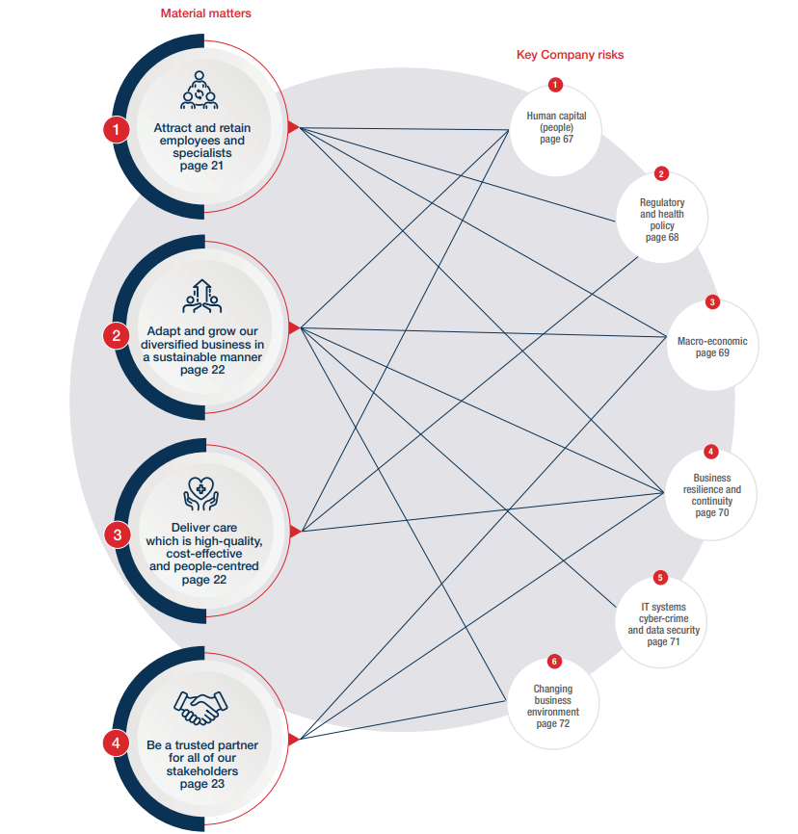
Source: Life Healthcare Group Holdings Limited. (2024). Integrated Annual Report 2024 (p. 20). Retrieved from https://www.lifehealthcare.co.za/media/4041/life-healthcare-iar-2024_singles-final.pdf
Appendix C: Material Matters and Key Company Risks
This diagram presents Life Healthcare’s key strategic priorities (material matters) alongside the company’s significant risks. It shows how the areas that matter most to the organisation’s long-term value creation are interconnected with the risks that could impede that value-creation, emphasising an integrated approach to strategy and risk management (Life Healthcare, 2021).

12.4 Appendix D: Risk Appetite
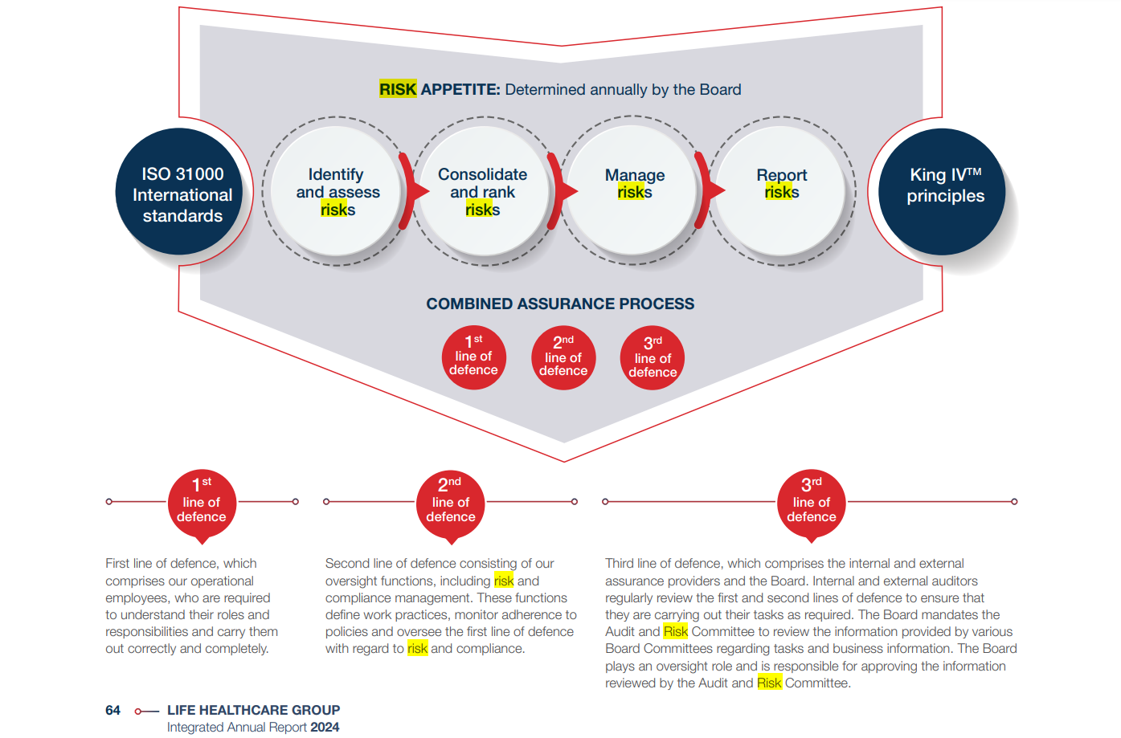
Source: Life Healthcare Group Holdings Limited. (2024). Integrated Annual Report 2024 (p. 64). Retrieved from https://www.lifehealthcare.co.za/media/4041/life-healthcare-iar-2024_singles-final.pdf
This figure illustrates Life Healthcare’s risk appetite framework and the three lines of defence model used to manage enterprise risks in accordance with ISO 31000 and King IV principles. The first line of defence comprises operational employees responsible for day-to-day risk management; the second line encompasses oversight and compliance functions ensuring adherence to policies; and the third line includes internal and external assurance providers, as well as the Board, who evaluate the effectiveness of the first two lines. Together, these layers support the group’s combined assurance process in identifying, consolidating, managing, and reporting risks (Life Healthcare, 2021).

